Dear Editor,

Enclosed please find our manuscript “Density fluctuations and energy spectra of 3D bacterial suspensions”, which we are pleased to submit to *Physical Review X*.

Observed in a wide range of living and non-living systems, giant number fluctuations (GNF) have been generally considered as one of the hallmarks of the emergent dynamics of active fluids. Nevertheless, the existing experiments on GNF all focused on dry 2D or quasi-2D systems. Density fluctuations in 3D wet active fluids, where long-ranged hydrodynamic interactions play the leading role in determining the dynamics of active fluids, have not been experimentally investigated heretofore. Here, we conduct systematic experiments exploring both the density fluctuations and the energy spectra of bulk bacterial suspensions over a wide range of bacterial concentrations. Our experiments first confirm the theoretical prediction on the scaling relation of GNF in 3D wet active fluids. Surprisingly, we find that such a scaling persists at small length scales even in low-concentration suspensions, well before the suspensions display a long-range orientational order. In addition, our study on the energy spectra of bacterial suspensions also fills in the experimental knowledge gap on the density-dependent variation of the energy spectra of active fluids. Our results provide not only the first verification of the theoretical prediction on the energy spectra of dilute pusher swimmers but also a solid experimental benchmark for understanding the spectral properties of the active turbulence of dense bacterial suspensions in the bulk limit. Finally and more importantly, our study reveal a density-independent and scale-invariant correlation between GNF and energy spectra of bacterial suspensions across length scales extending from the size of single bacteria to the size of the entire system. Such an unusual correlation exists not only in the steady active turbulence but also in the transient state during the transition towards active turbulence. Taken together, our study provides experimental verification of several important theoretical predictions including the scaling relation of GNF in 3D wet active fluids, the energy spectra of dilute suspensions of pusher swimmers, and the delayed onset of density fluctuations in the kinetic process. More importantly, our experiments reveal unexpected dynamic features of active bacterial suspensions such as the strong bacterial density correlation at the small scales in dilute suspensions and the universal coupling between GNF and energy spectra across a wide range of length scales in both the steady and transient active turbulence. We believe our results make an important contribution to the understanding of the dynamics of active fluids and should be of general interests to both experimentalists and theorists in the field of active fluids, soft matter and biophysics.

The main text of our manuscript contains nine figures. A supplementary video is also submitted along with the main text.

Thanks for considering our manuscript.

Sincerely yours,

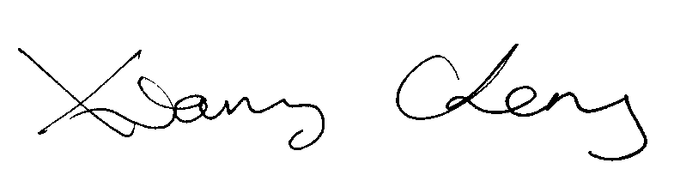

Xiang Cheng

On the behalf of all the co-authors